A Platform Advocating for Transparency, Visibility, and Equality
Amanda Attar
for QIAA Vice-President
2018 to 2019

About Me

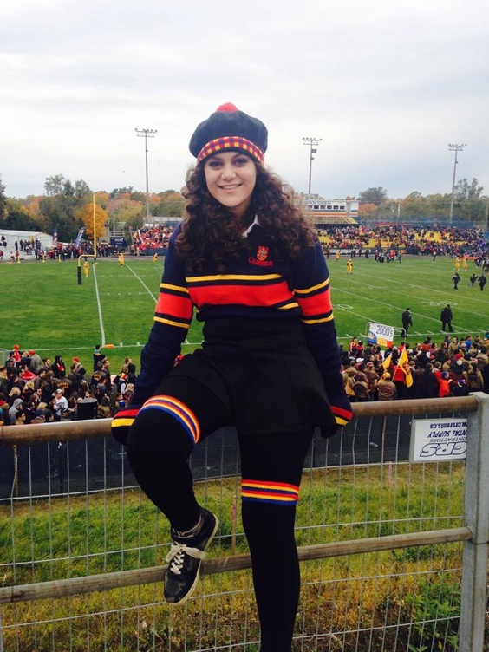
Hello there!

I am Amanda Attar and I am a third year student in Philosophy here at Queen’s. I may not study Politics, but in the two years I have been involved with Queen’s International Affairs Association, I have learned a ton about the political climate both locally and internationally! I got my start to QIAA later than most- I joined the MUN team in second year. Quickly, QIAA took over my life. I got involved with QMUNi. I started reading articles from the Observer. Then I ran for Logistics Coordinator to get my feet wet on the Leadership of QIAA. I loved it so much that I am now running for Vice-President. I cannot tell you how glad I am that I left the Queen’s Debating Union for Queen’s International Affairs Association.

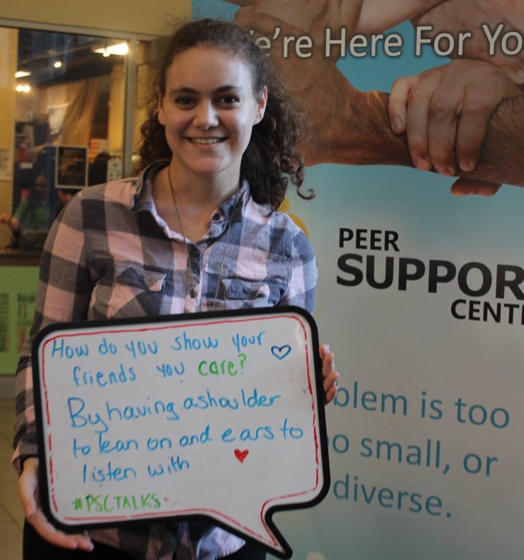
My qualifications for the Vice President of QIAA come from my experience in my commitments to various clubs on campus. As Logistics coordinator for the Model United Nations team, I learned how complicated organizing lodging and delegate fees for conferences was. As a QICSIM researcher I learned that background guides are not easy and require research, dedication and collaboration for cohesion and continuity. As a Chair for QMUNi I understood the kind of communication and team work that is required to make a committee, or any other group-based initiative, progress smoothly. As a delegate at RMC I learned how to raise my voice and push for what I want while working with others to ensure my goals were achieved. As a Public Relations officer for Queen’s Role Play Games Society I learned how to facilitate inclusion of minorities and to tackle issues of power imbalance and deal with cases harassment. As the Marketing Director for the Philosophy Department Student Council I learned how to develop and market events to ensure the greatest amount of participation, inclusion, and enthusiasm.

The key word here is learned. I have been learning throughout all of my experiences at Queen’s. I hope that you will elect me as Vice President so I can continue to do just that: learn. Learn how to be the best possible Vice President for you. I have three pillars: transparency, visibility, and equality. I plan to honour those, if elected, throughout my term as Vice President. I will be open, honest, and equal both in myself and to my treatment of others. I will attend at least one event every QIAA initiative makes. I promise that I will be easy to find and connect with. Most importantly, this platform will show you that I will listen to you and what you want to see out of QIAA and out of me. I will fulfil all my responsibilities without sacrificing these core values.

QIAA executives are elected by the students in QIAA to represent and lead. As such, the meetings and decisions that take place should be transparent to the people they are responsible to: you. As such, I will work to publish all meeting minutes from General Meetings and updates after executive meetings so you, the members, know how I am working to serve QIAA better. As such, I can be held fully accountable to my position and the members of QIAA.
Transparency

QIAA is the largest non-academic club on campus. We run a plethora of events all over campus. However, we can always work to be more visible both in our in-house initiatives, and over campus. Visibility requires us to do bake sales and marketing in the ARC, hold our banner in Mac-Correy, and show ourselves to Frosh in Vic Hall. We do not want to stop campaigning for individuals to join us after Frosh Week. We need to make sure all our initiatives are known and open to the students so we can ensure we get as much attention as possible. Increasing visibility is fundamental to sustaining our status as a large, diverse club on campus.
Visibility

As Queen’s becomes a more socially-aware campus, our clubs need to share the right mindset. As such, we need to make an active attempt to recruit and maintain individuals from all different walks of life. This is no easy feat. However, we need to work with other groups on campus to ensure we are encouraging as many people as possible to join QIAA so we can break the gender, race, age, and sexual orientation barriers that we still have today. We cannot wait for individuals to reach out to us. Instead, we must actively seek out partnerships with organizations that are already doing their part to support the participation of all minority groups on campus.
Equality

The biggest change I plan to make for QIAA is to increase connectivity between all of QIAAs initiatives. QIAA does so many amazing things and should cross market their initiatives in order to ensure as much participation is possible. People on the MUN team should be going to IDW and the writers for The Observer should get updates on Right of Reply. By marketing these initiatives together, we can create more participation.
My General Goals
The Observer
This year, we have seen a shift in the Observer to feature Magazine-esque stories that would appeal to greater audiences. I would like to continue on this trend by allowing for creative perspectives as a means to explaining the political tensions worldwide. This would include, but is not limited to, art pieces, poems, short stories and white papers. I would like to transform the Observer to feature interviews with the people we talk about in our stories. We can contact exchange students from the countries we write on to get a viewpoint from someone who actively experiences the political issues we study from a far. This ensures the Observer can be both opinionated and feature truthfully sourced information.

QIAA has used right of reply to discuss intense political affairs. I would like to expand right of reply to deal with International issues that apply critically to Queen’s students. For example, I think a session that discusses the international trend of sex inequality and how it applies differently in Canada and the United States from other countries would be a topic of large interest to more students at Queen’s considering the frightening trend of sexual assault increasing on campus. Furthermore, I would like Right of Reply to have a larger presence on campus Right of Reply can team up with the Observer to feature some of its interviews printed out into its issues. The Observer can also write analysis on these interviews to encourage cross viewership.
Right of Reply

Speakers Series is a fantastic initiative by QIAA that would do well with major rebranding. Rather than the current branding strategy that focuses on promoting the political climate, Speaker Series will benefit from changing its focus. I will advertise Speaker Series as a means to “learn what to do with your Politics degree” or “how to turn your interest in International Affairs into a career”. This will appeal to the many individuals on campus who are struggling to find out what career options their academics will grant them. Speaker Series’ notes, like Right of Reply, can be put in the Observer to expand interest. Furthermore, we should reach out to QIAA members and the Queen’s community at large to see what current events issues they are interested in and present speakers who are related to those interests.
Speaker Series

International Development Week focuses on international poverty. To improve local interest in IDW, I will work to connect it with both a Queen’s Organization, and a Kingston or Ontario-wide Organization. This partnership will increase the attendance and advertising IDW receives both within Queen’s and in our Kingston community. The more individuals that can get involved, the more we can fundraise towards charities and initiatives that provide critical support resources to those living in Poverty.
International Development Week
Model United Nations
If elected, I will reach out to members of the MUN team to ask what topics they are interested in so we can make committees appeal to them. I will do this at the beginning of the school year to give the executives plenty of time to either find previous conference background guides that appeal to these interests, or create innovative, fun background guides that team members are inclined towards. I will also work with the MUN team to provide background guides further in advance of meetings so members have more time to read ahead on the issues. I believe the MUN team needs to work on two important aspects: new member training and returning member meeting commitment. As a supplement to the introductory meeting on procedure, the MUN directors can offer online videos or seminars that go into more specifics about how MUN works. These videos can be posted as a resource on the QIAA website or a YouTube channel that individuals can look up on their own time, rather than being restricted to a weekly schedule. After these videos are made, we can keep them up for members to continue to look at. These videos also ensure that students who are busy and cannot make meetings have access to important MUN rules and tips that they need to succeed. On returning members attending meetings, we need to keep attendance of who shows up so we can reward the members who commit by giving them their preferred tournaments. First position choices should be given to members who have demonstrated a commitment to meetings and actively participate. This ensures that members who show up but are obviously distracted or not properly participating now have an incentive to set a positive role model for other members.
Queen’s Model United Nations Invitational
QMUNI is an amazing opportunity for other students to come to our campus and have a MUN tournament in both a demanding but educative environment. QMUNi combines experienced high-caliber delegates with newcomers to provide a solid ground for learning while being in a comfortable atmosphere. The largest issue with QMUNi comes not from its organization or events but from its socials. One social is always 19+. This is a restrictive requirement that we should attempt to remove. We should make our socials all ages so everyone feels included and welcome to them.

QICSIM, like MUN, should work with members of QIAA to determine what they would like to participate in. QICSIM should focus on relevant issues to the students of Queen’s. I will promote a QICSIM that targets the specific political and social controversies that are not only student-influenced. I will advocate for crises that require complex problem solving skills that would actively serve participants well for their studies and future careers. I think QICSIM marketing needs to be reworked. We should be advertising QICSIM to new members and to students outside of QIAA who are interested in imagination-based simulations. Other very diverse clubs on campus would take interest to the simulation style of activity that is required of QICSIM. Rather than restricting ourselves to the QIAA organization, QICSIM is a great way to get QIAA outsiders into QIAA, and hopefully to QIAA’s other initiatives by extension.
Queen’s Interactive Crisis Simulation

In conclusion, I would be honoured to be your Vice-President of QIAA because I know that I will learn more about the club I love and value so much. I am confident that my abilities will help QIAA establish the goals I have set for next year. If you have any questions about my platform, please do not hesitate to contact me! I hope that I can continue to learn by being your QIAA Vice-President. My email is 14aa100@queensu.ca!
Conclusion

